ESCUELA ADMINISTRACIÓN Y COMERCIO
“FORMANDO PERSONAS, CONSTRUYENDO FUTUROS”
___________________________________________________________________________________________
Unit 1: “My clothes” - 3rd grade

Activity 1: Look at the images and write the vocabulary: clothes, use words from the box // Mira las imágenes y escribe el vocabulario: prendas de vestir, usa las palabras del recuadro.
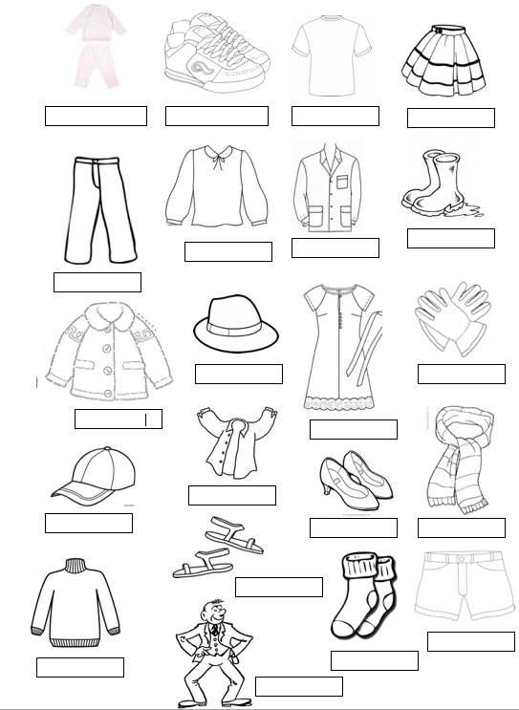
CAP
SOCKS
SKIRT
GLOVES
TRACKSUIT
DRESS
PANTS
T-SHIRT
SHOES
TRAINERS
SUIT
SHIRT
HAT
BLOUSE
SANDALS
SWEATER
BOOTS
JACKET
SCARF
SHORT
APRON

Activity 2: Crossword, write clothes//Crucigrama, escribe las prendas de vestir.
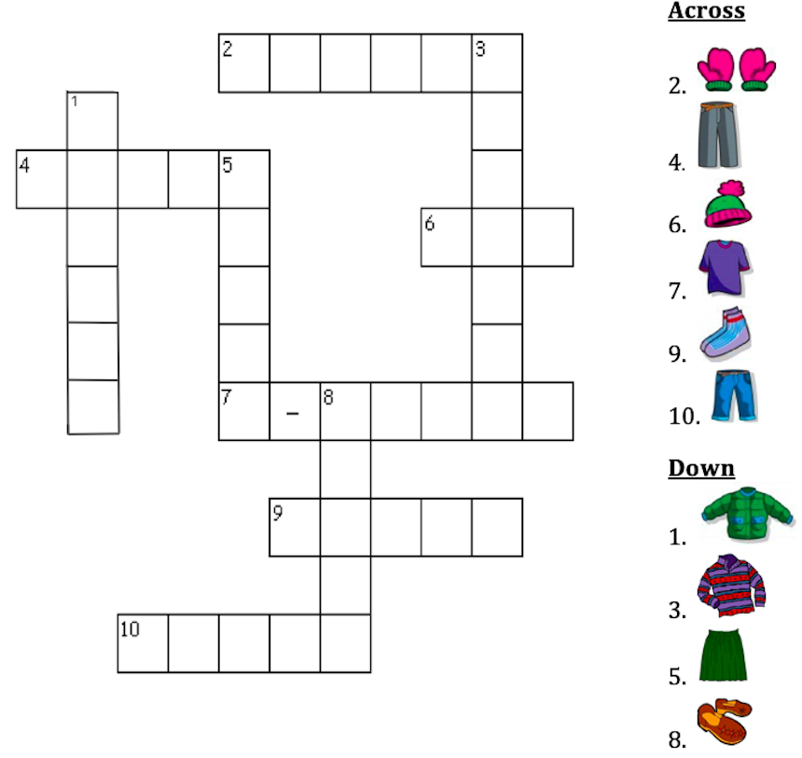

Activity 3: Read, draw and color // Lee, dibuja y colorea.
A yellow dress | The t-shirt is red | A green scarf | My boots are black | A blue jacket
My hat is purple | A pink skirt | The sweater is brown | The gloves are orange | A grey suit

